A Brief Introduction to RTL8192C driver Power Saving

1.) Normal power saving
1-1.) RTL8192C consists of two power modes:
A). Minimum Power Saving mode.
In this PS mode, RTL8192C wakes up every beacon interval. Figure 1 shows the RTL8192C power consumption under Minimum Power Saving mode.

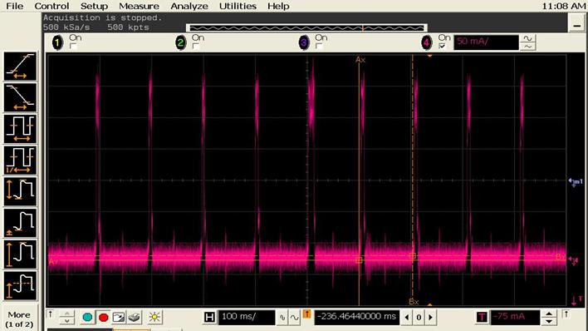
Figure 1. Minimum Power Saving mode (Associated idle)

B). Maximum Power Saving mode:
When driver be set to maximum power saving mode, which means RTL8192C wake up to receive beacon when DTIM count of beacon is zero.
If DTIM period of beacon is 3 RTL8192C would wake up every 3 bacon interval. Figure 2 illustrates RTL8192C power consumption under Maximum Power Saving mode:

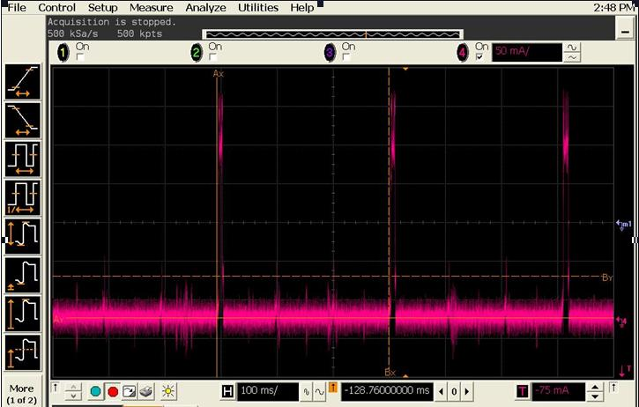
Figure 2. Maximum Power Saving mode (Associated idle)

1-2.) The following document will describe the way to let this driver to enable the power saving functionality.
===========================================================
A.) Power Saving Mode – by modify Makefile
===========================================================
You can easy set the power saving to Min-PS (rtw_power_mgnt=1) by modify the CONFIG_POWER_SAVING to y, at the line 20 of Makefile file.
Ex:
CONFIG_POWER_SAVING = y

===========================================================
B.) Power Saving Mode – by change load-time parameters
===========================================================
(1) In order to enter PS Mode, you need to add the parameter of "rtw_power_mgnt=1" when executing "insmod 8192cu.ko" :
$>insmod 8192cu.ko rtw_power_mgnt=1
or
$>insmod 8192cu.ko rtw_power_mgnt=2

(2)Parameter Notes:
rtw_power_mgnt=1 ;//enable PS, MIN_PS Mode
rtw_power_mgnt=2 ;//enable PS, MAX_PS Mode
2-1.) Dynamic suspend in USB subsystem
A particular device can turned off while the system as a whole remains running, we call it a "dynamic suspend". (also known as a "runtime suspend" or "selective suspend").

2-2.) The following document will describe the way to let this driver to enable the dynamic suspend functionality.

===========================================================
A.) By modify Makefile
===========================================================
You can turn on dynamic suspend function by modify the CONFIG_USB_AUTOSUSPEND to y, at the line 21 of Makefile file.
Ex:
CONFIG_USB_AUTOSUSPEND = y

===========================================================
B.) By change load-time parameters
===========================================================
(1) You can turn on or turn off the dynamic suspend by adding the following parameter.
$>insmod 8192cu.ko rtw_power_mgnt=1 rtw_enusbss = 1
or
$>insmod 8192cu.ko rtw_power_mgnt=1 rtw_enusbss = 0
or
$>insmod 8192cu.ko rtw_power_mgnt=2 rtw_enusbss = 1
or
$>insmod 8192cu.ko rtw_power_mgnt=2 rtw_enusbss = 0

(2)Parameter Notes:
rtw_enusbss = 1; // enable USB’s dynamic suspend
rtw_enusbss = 0; // default, disable USB dynamic suspend

3-1.) WIFI Radio on / off detection
===========================================================
A.) By modify Makefile
===========================================================
You can turn on this function by modify the CONFIG_HW_PWRP_DETECTION to y, at the line 22 of Makefile file.
Ex:
CONFIG_HW_PWRP_DETECTION = y

===========================================================
B.) By change load-time parameters
===========================================================
(1) If you want turn on this function in load time, you need to add the parameter of " rtw_hwpwrp_detect =1" when executing "insmod 8192cu.ko" :
$>insmod 8192cu.ko rtw_hwpwrp_detect =1

(2)Parameter Notes:
rtw_hwpwrp_detect =1 ;//enable wifi rf on/off detection
rtw_hwpwrp_detect =0 ;//disable wifi rf on/off detection

4.) Power consumption example

Scenario (unit: mA) @5V | RTL8188CUS
Associated Idle | 85.6
Unassociated Idle | 80.2
Associated Idle (enable power save) - LPS | 34.5
Unassociated Idle (enable power save) - IPS | 18.9
Unassociated Idle (enable selective suspend) | 0.72

